# Debugging Challenge Worksheet

Instructions: Below are sample code snippets with errors. Identify the errors, correct the code, and explain your corrections. Complete this worksheet in pairs or individually, then discuss your answers as a group.

## Debugging Question 1

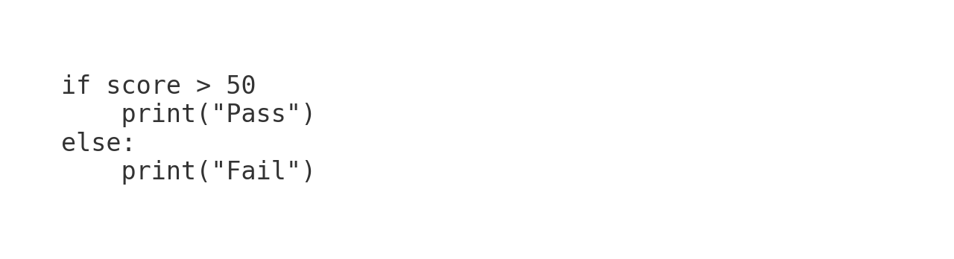

- **What is wrong with the code?** :

- **Corrected Code:** if score > 50:

- **Explanation:** the line of code is missing a ‘:’ for the statement

## Debugging Question 2

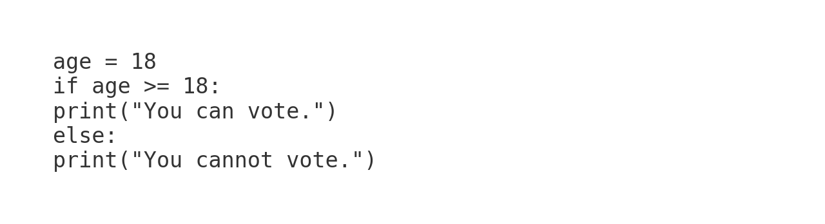

- **What is wrong with the code?** the print lines require indentation

- **Corrected Code:**

- **Explanation:** when the code is not indented to the if-else statement it isn’t linked to the statement output

## Debugging Question 3

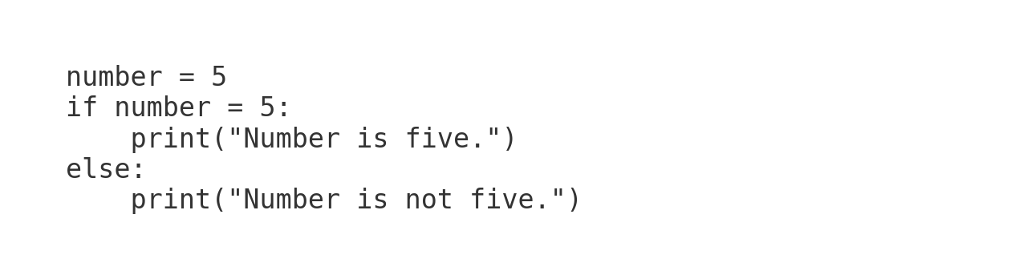

- **What is wrong with the code?** ==

- **Corrected Code:** if number == 5:

- **Explanation:** The code for defining what number is in the if-else statement should be a ‘==’ as this defines the statement as both sides being equal. Whereas a ‘=’ defines the statement as number defines 5

**Stretch Task:** Modify the program to include a message "Excellent" if the score is above 90. Write your code below:  
  
[Space for code].

# Discussion

Once you complete the corrections, discuss your solutions with your group and reflect on how these types of errors can be avoided in the future.